**Compliance and Regulatory Affairs in Banking Operations**

**1. Regulatory Framework:**

The U.S. banking sector is governed by a complex regulatory framework involving multiple federal agencies. The Federal Reserve (Fed) oversees the stability and monetary policy of the banking system, regulating bank holding companies and state-chartered banks that are members of the Federal Reserve System. The Office of the Comptroller of the Currency (OCC) charters, regulates, and supervises national banks and federal savings associations, ensuring their safe and sound operation. The Federal Deposit Insurance Corporation (FDIC) insures deposits at banks and savings associations, and it also supervises these institutions for safety, soundness, and consumer protection. The Consumer Financial Protection Bureau (CFPB) enforces federal consumer financial laws, safeguarding consumers from unfair, deceptive, or abusive practices and overseeing consumer financial products and services. Each of these regulatory bodies has specific mandates and areas of focus, which collectively aim to maintain the integrity and stability of the U.S. financial system. Banks must navigate this regulatory landscape, adhering to the guidelines and requirements set forth by these agencies to ensure compliance and avoid penalties, which necessitates robust internal compliance mechanisms and continuous monitoring.

**2. Compliance Functions:**

Compliance functions in banks are crucial for adhering to legal and regulatory requirements. A key component is Anti-Money Laundering (AML) programs, which detect and report suspicious activities. AML programs include customer due diligence (CDD), transaction monitoring, and filing suspicious activity reports (SARs) to the Financial Crimes Enforcement Network (FinCEN). Know Your Customer (KYC) procedures involve verifying customer identities during account opening and periodically updating their information to prevent fraud and money laundering. Data privacy and security are also critical, with compliance to laws like the General Data Protection Regulation (GDPR) and the California Consumer Privacy Act (CCPA) ensuring customer data protection and privacy rights. Robust cybersecurity measures are essential to safeguard sensitive information. Additionally, fair lending practices are mandated under laws like the Equal Credit Opportunity Act (ECOA) and the Fair Housing Act (FHA), which prohibit discrimination based on race, color, religion, sex, national origin, marital status, age, or receipt of public assistance. These compliance functions collectively help banks maintain ethical standards, protect customer interests, and avoid legal repercussions.

**3. Risk Management:**

Risk management in banking is a comprehensive process that involves identifying, assessing, monitoring, and mitigating various risks to ensure the institution's stability and integrity. Operational risk management addresses risks arising from internal processes, people, systems, and external events. This includes implementing robust internal controls, conducting regular audits, and establishing contingency plans. Market risk management involves mitigating exposure to fluctuations in market prices, such as interest rates and foreign exchange rates, using financial instruments and hedging strategies. Credit risk management focuses on assessing the creditworthiness of borrowers and managing the risk of default. This involves rigorous credit assessments, setting appropriate loan terms, and diversifying the loan portfolio. Compliance risk management ensures that the bank adheres to all applicable laws and regulations, requiring ongoing training, policy updates, and compliance monitoring. Effective risk management is critical for maintaining the bank's financial health, protecting against potential losses, and ensuring compliance with regulatory requirements. By proactively managing risks, banks can safeguard their assets, reputation, and overall stability.

**4. Reporting Requirements:**

Banks in the U.S. must comply with extensive reporting requirements to ensure transparency and regulatory compliance. Regular regulatory reports include the Call Report, submitted to the FDIC, which provides detailed financial information about the bank, and the FR Y-9C report, submitted to the Fed, for bank holding companies. These reports are essential for regulatory oversight and monitoring the financial health of institutions. Additionally, banks must file Suspicious Activity Reports (SARs) with FinCEN when they detect potentially suspicious or criminal activities, aiding in the prevention of financial crimes. Currency Transaction Reports (CTRs) are required for transactions involving more than $10,000 in cash, helping detect and prevent money laundering and other illicit activities. Capital adequacy reports, required under the Basel III framework, ensure that banks maintain sufficient capital to absorb potential losses, promoting financial stability. These reporting requirements are crucial for maintaining transparency, accountability, and regulatory compliance, allowing regulatory bodies to monitor and address potential risks in the banking sector effectively.

To provide a detailed analysis of compliance and regulatory affairs in banking operations we need to focus on relevant metrics from past year data and current year data.

**Hypothetical Data**

**Compliance & Regulatory Affairs Metrics**

|  |  |  |
| --- | --- | --- |
| **Metric** | **2022** | **2023** |
| Number of Regulatory Reports | 1200 | 1300 |
| Suspicious Activity Reports (SARs) Filed | 900 | 1100 |
| Penalties for Non-Compliance ($ Million) | 10 | 8 |
| Number of Data Breaches | 5 | 3 |
| Average Time to Resolve Compliance Issues (Days) | 45 | 35 |

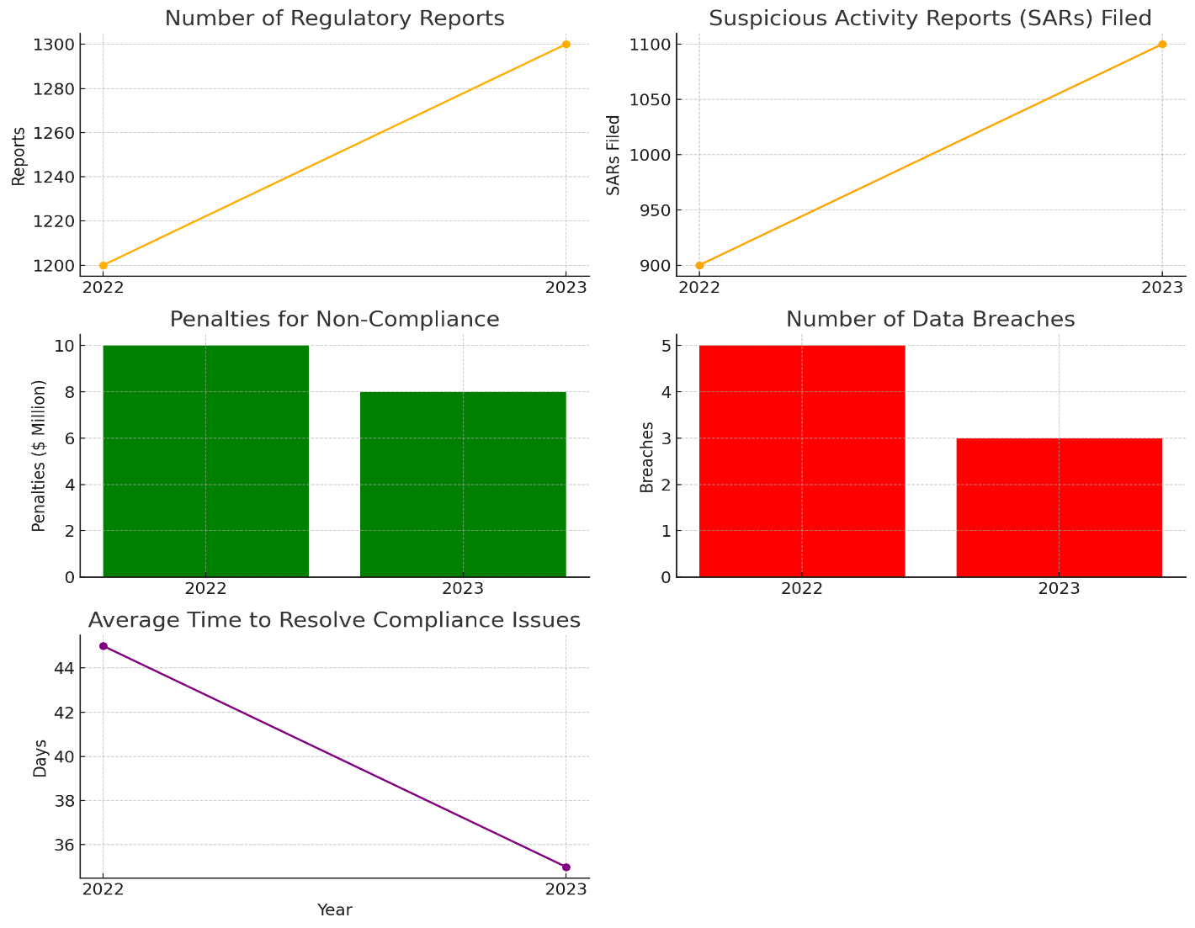

**Interpretation of the graphs**

**Compliance and Regulatory Affairs Metrics**

**1. Number of Regulatory Reports:**

- The line chart shows an increase from 1200 reports in 2022 to 1300 reports in 2023. This suggests that banks are either under increased regulatory scrutiny or have improved their reporting practices.

**2. Suspicious Activity Reports (SARs) Filed:**

- The orange line indicates a rise from 900 SARs filed in 2022 to 1100 in 2023, reflecting better detection and reporting of suspicious activities.

**3. Penalties for Non-Compliance:**

- The green bar chart reveals a decrease in penalties from $10 million in 2022 to $8 million in 2023, indicating improved compliance practices among banks.

**4. Number of Data Breaches:**

- The red bar chart shows a reduction in data breaches from 5 incidents in 2022 to 3 in 2023, highlighting stronger cybersecurity measures.

**5. Average Time to Resolve Compliance Issues:**

- The purple line chart indicates a decrease in resolution time from 45 days in 2022 to 35 days in 2023, showcasing enhanced efficiency in addressing compliance issues.

**Customer Relationship Management (CRM) in Banking**

**1. Data Management:**

Effective CRM in banking hinges on robust data management, which involves integrating customer data from multiple sources such as online banking, mobile apps, and branch visits to create a comprehensive view of each customer. This holistic approach enables banks to understand customer behaviors, preferences, and needs more accurately. Real-time data processing capabilities allow banks to analyze and respond to customer activities and trends promptly. By leveraging advanced data management systems, banks can ensure data accuracy, consistency, and security, which are critical for making informed decisions and providing personalized services. Data management also includes maintaining up-to-date customer records, ensuring compliance with data protection regulations like GDPR and CCPA, and implementing strong cybersecurity measures to protect sensitive information. Overall, efficient data management enhances the bank's ability to deliver tailored products and services, improve customer satisfaction, and build long-term relationships.

**2. Customer Segmentation:**

Customer segmentation is a pivotal aspect of CRM, enabling banks to categorize customers into distinct groups based on various criteria. Demographic segmentation involves grouping customers by age, gender, income level, education, and occupation, allowing banks to tailor marketing strategies and product offerings to specific demographic groups. Behavioral segmentation analyzes customer behaviors, such as transaction history, product usage, and online interactions, to deliver personalized services and communications. Profitability segmentation focuses on identifying and prioritizing high-value customers, optimizing resource allocation, and enhancing customer relationship management efforts. By understanding the unique needs and preferences of different customer segments, banks can develop targeted marketing campaigns, design customized financial products, and provide superior customer service. Effective segmentation enhances customer satisfaction, loyalty, and profitability, ultimately driving business growth.

**3. Improving Customer Experience:**

Enhancing customer experience is a core objective of CRM in banking. Personalized services, enabled by CRM systems, allow banks to offer tailored financial products and advice based on individual customer needs and preferences. This includes personalized product recommendations, customized communication, and proactive financial planning assistance. Providing an omnichannel experience ensures that customers receive consistent and coordinated service across various touchpoints, such as branches, online banking, mobile apps, and call centers. CRM tools facilitate seamless integration and synchronization of customer interactions, improving service quality and efficiency. Proactive support, powered by CRM insights, enables banks to anticipate customer needs and address issues before they escalate, enhancing customer satisfaction and loyalty. By focusing on improving customer experience, banks can build stronger relationships, increase retention rates, and differentiate themselves in a competitive market.

**4. Cross-Selling and Upselling:**

Cross-selling and upselling are critical strategies in banking CRM aimed at maximizing customer value and profitability. Cross-selling involves offering additional products and services that complement the customer's existing portfolio, such as suggesting a credit card to a customer with a savings account. CRM systems analyze customer data to identify cross-selling opportunities based on their financial behavior and needs. Upselling, on the other hand, entails offering higher-value products or services that better meet the customer's evolving needs, such as upgrading a standard credit card to a premium one with more benefits. By leveraging CRM insights, banks can personalize their sales approaches, making relevant and timely offers that enhance customer satisfaction and loyalty. Effective cross-selling and upselling strategies not only increase revenue but also strengthen customer relationships by providing value-added services that align with their financial goals.

**5. Analytics and Reporting:**

Analytics and reporting are vital components of CRM in banking, providing actionable insights into customer behavior, preferences, and trends. CRM analytics enable banks to track key performance indicators (KPIs) such as customer acquisition, retention rates, and customer satisfaction scores. These metrics help banks evaluate the effectiveness of their CRM strategies and identify areas for improvement. Predictive analytics, powered by advanced CRM systems, forecast customer behavior and trends, allowing banks to make data-driven decisions and plan future strategies. Detailed customer insights derived from CRM analytics help banks understand customer needs better, refine marketing efforts, and enhance product offerings. Regular reporting ensures transparency and accountability, enabling banks to monitor CRM performance and make informed adjustments to their strategies. By leveraging analytics and reporting, banks can optimize their CRM initiatives, improve customer engagement, and drive business growth.

To provide a detailed analysis of compliance and regulatory affairs in banking operations we need to focus on relevant metrics from past year data and current year data.

**Hypothetical Data**

**CRM Metrics**

|  |  |  |
| --- | --- | --- |
| **Metric** | **2022** | **2023** |
| Customer Satisfaction Score | 78% | 82% |
| Customer Retention Rate | 85% | 88% |
| Number of Cross-Sell Opportunities Identified | 5000 | 6500 |
| Revenue from Upselling ($ Million) | 50 | 65 |
| Average Response Time to Customer Inquiries (Hours) | 24 | 18 |

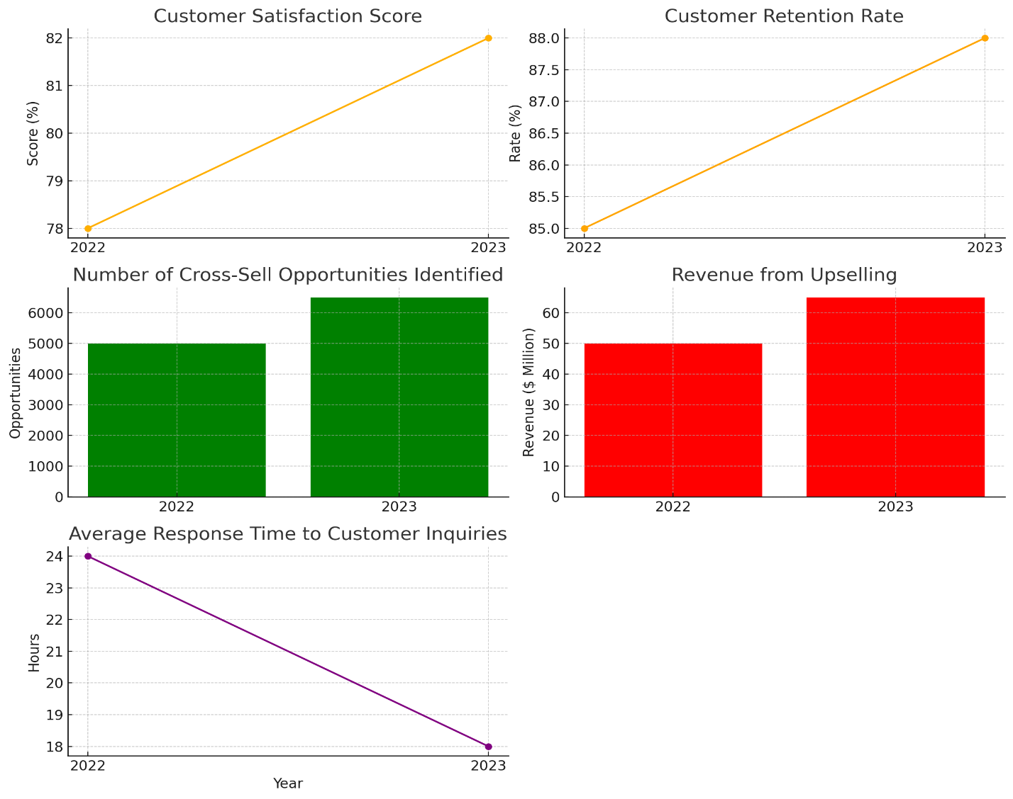

**Interpretation of the Graphs**

**CRM Metrics**

**1. Customer Satisfaction Score:**

- The line chart shows an improvement in customer satisfaction scores from 78% in 2022 to 82% in 2023, reflecting better customer service and engagement.

**2. Customer Retention Rate:**

- The orange line chart illustrates an increase in retention rates from 85% in 2022 to 88% in 2023, indicating higher customer loyalty and satisfaction.

**3. Number of Cross-Sell Opportunities Identified:**

- The green bar chart reveals a significant rise in identified cross-sell opportunities from 5000 in 2022 to 6500 in 2023, suggesting more effective use of customer data to offer relevant products.

**4. Revenue from Upselling:**

- The red bar chart shows an increase in revenue from upselling, from $50 million in 2022 to $65 million in 2023, highlighting successful upselling strategies.

**5. Average Response Time to Customer Inquiries:**

- The purple line chart indicates an improvement in response times, decreasing from 24 hours in 2022 to 18 hours in 2023, showcasing enhanced customer service responsiveness.

**Summary**

The graphs illustrate positive trends in both compliance and regulatory affairs as well as CRM in the banking sector. Banks have improved their compliance processes, reduced penalties, and enhanced cybersecurity, leading to fewer data breaches and quicker resolution times. On the CRM front, there have been improvements in customer satisfaction, retention rates, cross-selling opportunities, revenue from upselling, and response times to customer inquiries. These advancements indicate a stronger focus on regulatory adherence and customer relationship management, contributing to overall better performance and customer satisfaction in the banking industry.